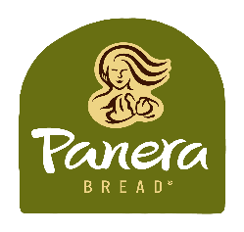
Salad and Sandwich Maker/Cashier
Full-time and part-time
Looking for a supportive workplace that prioritizes safety and has your back? Want to work where you can be yourself, become your best, and make people smile? Panera is for you.
Your safety is our priority.
We’ve implemented new procedures to protect you, our team, and our customers at all times – including during interviews, training, and all work shifts. You’re provided with masks, sanitizer, and enough space for social distancing.
- Our workspace sanitization procedures have been enhanced.
- We have zero cash transactions.
Delight customers with real food, real fast.
With dozens of menu items – and endless possible combinations – Panera’s kitchen is no fast-food assembly line. Our line cooks prep, cook, assemble, and plate soups, salads, grain bowls, sandwiches, and more – using nothing but real ingredients in every single order.
This opportunity is for you if:
- You enjoy working with food.
- You work well in a fast-paced environment.
- You want to be part of a fun, energized team that works hard and laughs often.
- You can understand and practice food safety procedures.
- You’re at least 16 years of age
Panera Perks
- Competitive pay – plus tips!
- Flexible schedules
- Free Employee Shift Meals (LLC only)
- Training, skill-building, and Career Path Program
- Paid time off
- Health benefits
- 401(k) - with company match
- And more!
- Equal Opportunity Employer

