Creating a CFNC Account and Using Major Clarity – Please Do Not Write on this Sheet!
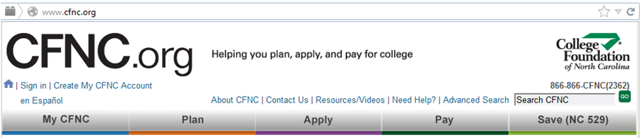
- Go to www.cfnc.org

- Click on Create My CFNC Account

- Beside High School Student Select Go
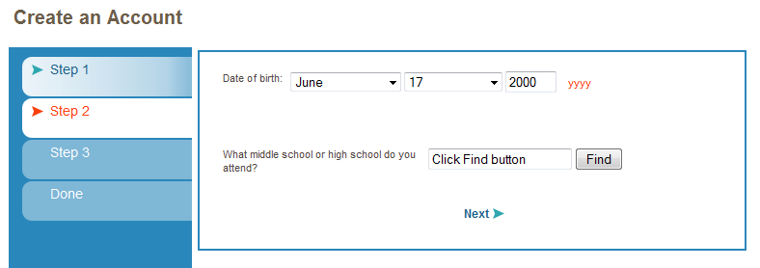
- Complete the Date of Birth section
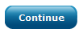
- To select our high school you MUST CLICK THE FIND BUTTON. Choose Apex High from dropdown box, then select

- (1 & 2) Type in your: First and Last Name.
(3) Scroll down to choose: Year of HS Graduation (2021).
(4 &5) Type in your: E-mail address (that you check most often).
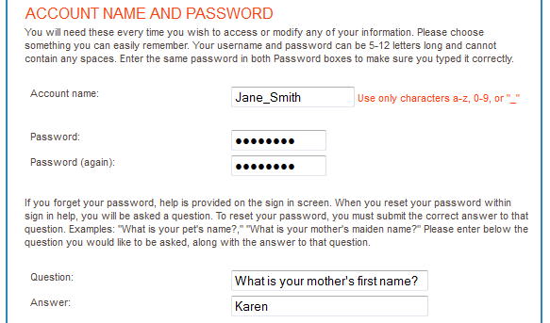
- CFNC will assign an Account Name (Write it on the small paper)
(1 & 2) Type in your Password (Write it on the small paper)
(3 & 4) Choose a Question & Answer

- Type in your Permanent address:
(1, 2, 3, & 4) Street, City, State, and Zip Code
For Mailing address: (5) Check the Box: Same as Above
(6) Gender: Scroll down & choose: Male (boy) OR Female (girl)
Step 2 - Next Step:
- Click Discover Your career interests
- Career Key – Answer the Quick Questions and it will generate your interests
- When you are finished Use the cap-sensitive Link here:https://goo.gl/Xjkp1W
- Answer the 5 Questions on Form (from the link above) and Submit for credit!
Step 3 - Last Step – Major Clarity:
- Student Account Setup Instructions:
1. Go to platform.majorclarity.com
2. Student’s email username: [Wake ID] + @students.wcpss.net a) Ex. jpanderson2@students.wcpss.net
3. Enter student password: [first 4 digits of last name] + [student ID number] (all lowercase,
hyphens and spaces are included) a) Example: clar1234567 or van-623411
b) For students with short last names, add spaces to reach 4 digits: yu 12334
4. Please complete the quick questionnaire on this site. Thank you.

